Proceedings XTerM 2019
Normandie Univ - Le Havre, France – June 26-28, 2019

URBAN MOBILITY UNDERSTANDING BASED ON COMPLEX NETWORK ANALYSIS
Author1, Author2 and Author3
Abstract. The abstract should be informative, precise and not exceed 200 words. Please do not include equations, tables and references in the abstract.
Keywords. At least 5 key words should be provided.

Introduction
Authors are required to state clearly the contributions of the paper in the Introduction. There should be some survey of relevant literature.
Submission of a manuscript to by the authors implies that the paper has not been previously published in any language and in any form, has not been copyrighted or submitted simultaneously for publication elsewhere, and that the copyright for the article will be transferred to the publisher upon acceptance of the article. The corresponding authors' e-mail addresses must be included in the manuscript.
Please make sure that all equations and figures do not run off the margins. Figures and Tables should be placed as part of the text, with descriptive captions and should be numbered consecutively. For LaTeX users, only stan- dards commands are allowed.
The following is taken from various papers, including figures without scientific meaning. The purpose is to show various editing usages.
Urban dynamic modeling plays an essential role in numerous social and engineering problems. It can be applied wherever random properties of a dynamical system have to be considered. Most of the emphasis is placed on the stability analysis of the stochastic dynamical systems (see [1]). Moreover, in many applications, the spatio-temporal processes are governed by more than one dynamics: the dynamics change among a family of choices with respect to time $t$ or state $x$. Such processes are often described by switched systems and have been studied extensively in recent years (see [5, 6]). Time-delay and uncertainties are two main causes for instability of dynamical systems (see [2]). Numerous studies have been carried out on stability analysis and stabilization of time-delay systems and uncertain systems (see [3, 4]), some of which have been done in the scope of stochastic systems or switched systems. To the best knowledge of the authors, few work has been done for switched stochastic systems with both uncertainties and time-delay. Some results are given by the figure 1.

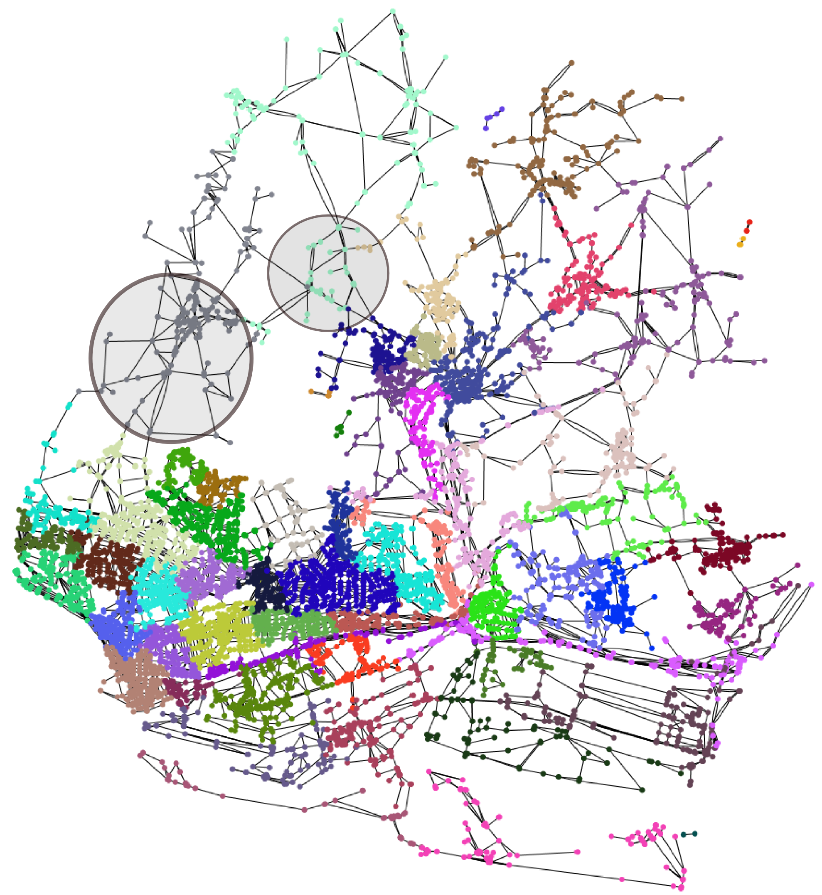
Figure 1: Road network clustering

Problem statement and preliminaries

Formulation
Consider the following stochastic uncertain switched system
$$dx\left(t\right)=\left[\left(A_{i}+∆A_{i}\right)x\left(t\right)+\left({\tilde{A}}_{i}+∆{\tilde{A}}_{i}\right)x\left(t-h\right)\right]dt+\left[\left(B_{i}+∆B_{i}\right)x\left(t\right)+\left({\tilde{B}}_{i}+∆{\tilde{B}}_{i}\right)x\left(t-h\right)\right]dw\left(t\right),$$ | (1)
$$x\left(t\right)=∅\left(t\right), t∈\left[-h,0\right],$$
where $x∈R^{n}$ is the state and $h$ is the constant time-delay.

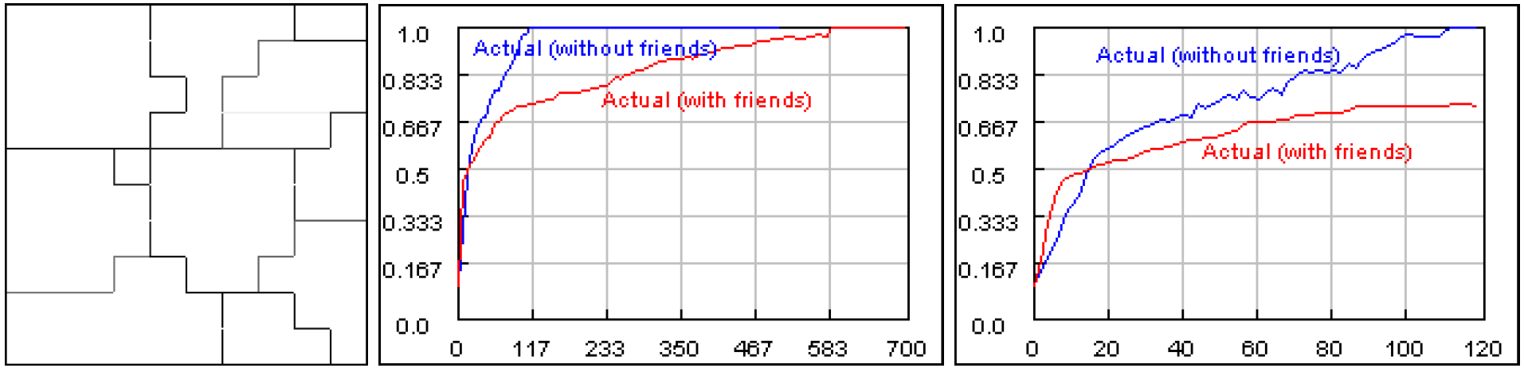
Figure 2: In this first experiment, typical outcome for a modified homogeneous Axelrod model is presented. (Left) An intermediate configuration in the case of partner selection. (Middle) Actual affinities with and without friends (partner selection). (Right) Zoom to the first part of the previous graph(first 120 cycles).
In the following, we describe some experiments.

Experiment 1. Modified Axelrod model (homogeneous) results with an initially diverse population (fig. 2). Partner selection does not change the final outcome which is full monoculture in the population, but it substantially retards the cultural contagion process. On the other hand, partner selection induces extremely fast local polarization as is depicted in fig. 2(left) where an intermediate configuration is shown, that is not possible without partner selection in this model. Fig. 2(right) shows the large speed of local convergence in the beginning of the experiment that slows down in what follows compared to the convergence speed without partner selection.

Stability
Two types of stability are considered in this paper, one is almost sure exponential stability and the other is ex- ponential stability in pth moment (see [5] for definitions). The main problem now can be formulated as follows:

Problem 2.1. For all admissible uncertainties, under what conditions will the uncertain switched system (1) be almost surely exponentially stable? Under what con- ditions will it be exponentially stable in mean square?

Main results
In this section, the stability analysis of system (1) is studied.

Table 1: Stability bounds of time-delay and average dwell time
$$T_{0}(×{10}^{3})$$ | 0 | 0.0856 | 0.2303 | 0.7960
$$h_{0}$$ | 0 | 0.5 | 1.0 | 1.5
$$T_{0}(×{10}^{3})$$ | 1.7645 | 3.0717 | 5.1803 | 9.2734
$$h_{0}$$ | 2.0 | 2.5 | 3.0 | 3.5
$$T_{0}(×{10}^{3})$$ | 23.4052 | 238.2837
$$h_{0}$$ | 4.0 | 4.4

The following matrix inequalities are satisfied:
$$ψ_{i}=\left[\begin{matrix}ψ_{11} & ψ_{12} & ψ_{13} \\ * & ψ_{22} & ψ_{23} \\ * & * & ψ_{33}\end{matrix}\right]<0,$$ | (2)
$$Q_{i}≤ρ_{i}I,$$ | (3)

Application
For different average dwell time lower bounds T0, the de- lay upper bounds h0 guaranteeing the exponential stability of the system are listed in Table 1.

Acknowledgment
The research for this work was supported, in part, by the Natural Sciences and Engineering Research Council of Canada.
.

References
- L. Arnold, Stochastic Differential Equations: Theory and Applications, John Wiley and Sons, 1974.
- S. Boyd, L. E. Ghaoui, E. Feron, and V. Balakrishnan, Linear Matrix Inequalities in System and Control Theory, SIAM,Philadephia, 1994.
- Y. Y. Cao, Y. X. Sun, and C. Cheng, “Delay-dependent robust stabilization of uncertain systems with multiple state delays,” IEEE Transactions on Automat. Control, vol. 43, pp. 1608- 1612, 1998.
- W.-H. Chen, Z. H. Guan, X. Lu, “Delay-dependent exponential stability of uncertain stochastic systems with multiple delays: an LMI approach,” Systems Control Lett., vol. 54, pp. 547-555, 2005.
- D. Cheng, “Stabilization of planar switched systems”, Systems Control Lett. vol. 51, pp. 79-88, 2004.
- J. Daafouz, P. Riedinger, C. Iung, “Stability analysis and con- trol synthesis for switched systems: a switched Lyapunov func- tion approach”, IEEE Trans. Automat. Control, vol. 47, pp. 1883-1887, 2002.

Author1 and Author2 are with Department of Applied Mathematics, University of Waterloo, Canada. E-mails: jnsa@uwaterloo.ca, john@uwaterloo.ca
Author3 is with Department of Civil and Environmental Engineering, University of Waterloo, Canada. E-mail: david@uwaterloo.ca

